Making the story for the Cervical Screening Paper – 2nd June 26

Abstract
Infection with Human Papillomaviruses (HPV) is a necessary cause of cervical cancer. England has vaccinated girls aged 12-13yrs against HPV since 2008: the oldest of this vaccine-eligible cohort are now screened. The current strategy invites all people with cervix to 5-yearly screening from age 25 (8 Lifetime Screens; LS), but this screening algorithm needs updating to incorporate vaccinations status. Using the Agent-Based Model HPVsim, validated to recent English data, we assess different screening frequencies according to individual (i) vaccine-eligibility, and (ii) vaccination status. We project cancer incidence rate per 100k and long-term undiagnosed cancer prevalence (LUDP) to 2050 in England.

We show that it remains necessary to screen all individuals, however screening frequencies can be reduced from 8 to 6 LS for unvaccinated vaccine-eligible and to 4 LS for vaccinated individuals, to keep projected incidence in line with the current policy.

- Projecting at 80\% vaccine coverage, a reduction from 8 to 4 LS in HPV-vaccinated/vaccine-eligible women leads to negligible population-level change in mean projected cervical cancer incidence rate (8LS: 2.6; 4LS: 2.7 / 2.8, 2050).

- Screening according to vaccine-eligibility leads to greater inequity with higher cancer incidence rate for the unvaccinated vaccine-eligible as screening frequency decreases (8/6/4 LS: 0.9/1.3/1.7, 2050). In contrast, a screening reduction for vaccinated individuals from 8 to 4 LS has negligible impact on incidence amongst the vaccinated (8/6/4 LS: 0.1/0.2/0.2, 2050), but incidence increases at lower screening frequencies (3LS: 0.4, 2050).

- While a reduction in vaccine uptake to 60\% will require more total screening for unvaccinated people across the population, individual lifetime screens can remain at 6 LS for the unvaccinated vaccine eligible and 4 for the vaccinated to retain current incidence rate projections.

- Under the current English screening policy, population-level cervical cancer elimination is unlikely by 2040, more likely by 2045, and very likely by 2050 (elimination probabilities 22\%; 75\%; 98\%).

As increasing numbers of HPV-vaccinated individuals become eligible for cervical screening, our work demonstrates the importance of taking vaccination status into consideration when designing cervical cancer screening strategies. We showcase a novel application of a complex Agent Based Model as a tool for evaluating personalised healthcare strategies at a national level.

Detail for RESULT 1
“Projecting at 80\% vaccine coverage, a reduction from 8 to 4 LS in HPV-vaccinated/vaccine-eligible women leads to negligible population-level change in incidence rate of cervical cancer (<1\% / 3\% median incidence increase 8LS: X; 4LS: Y1/Y2, 2050).”
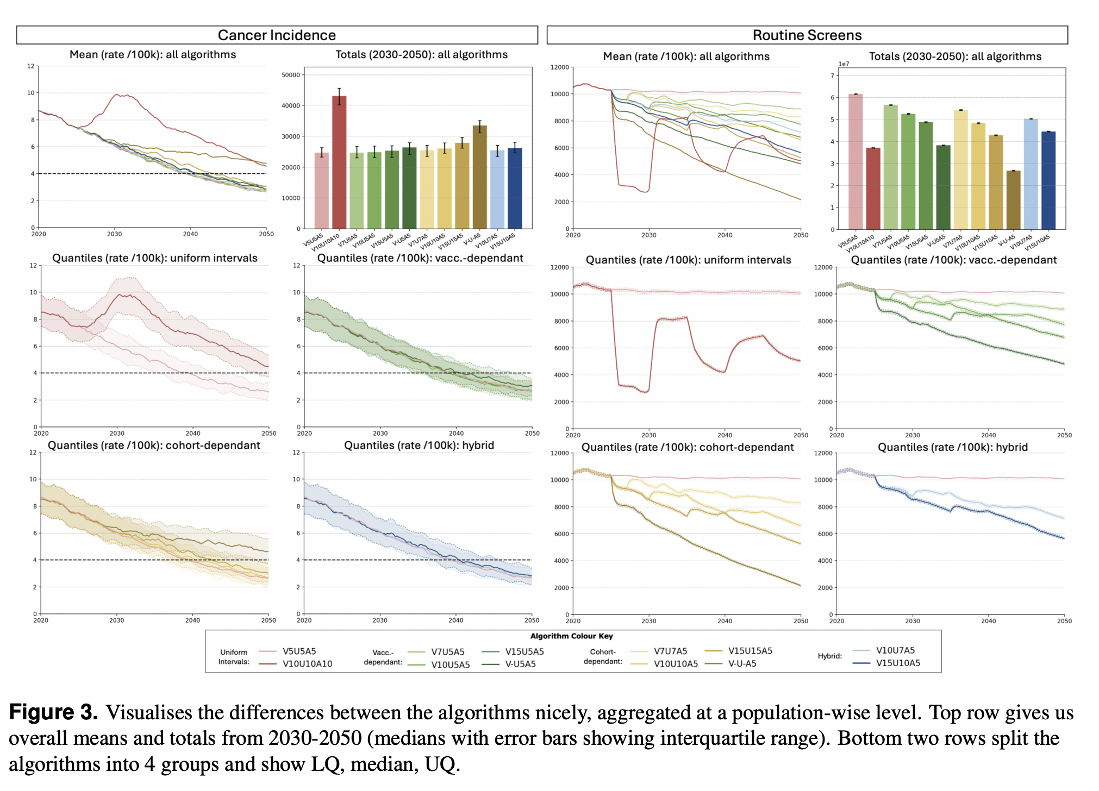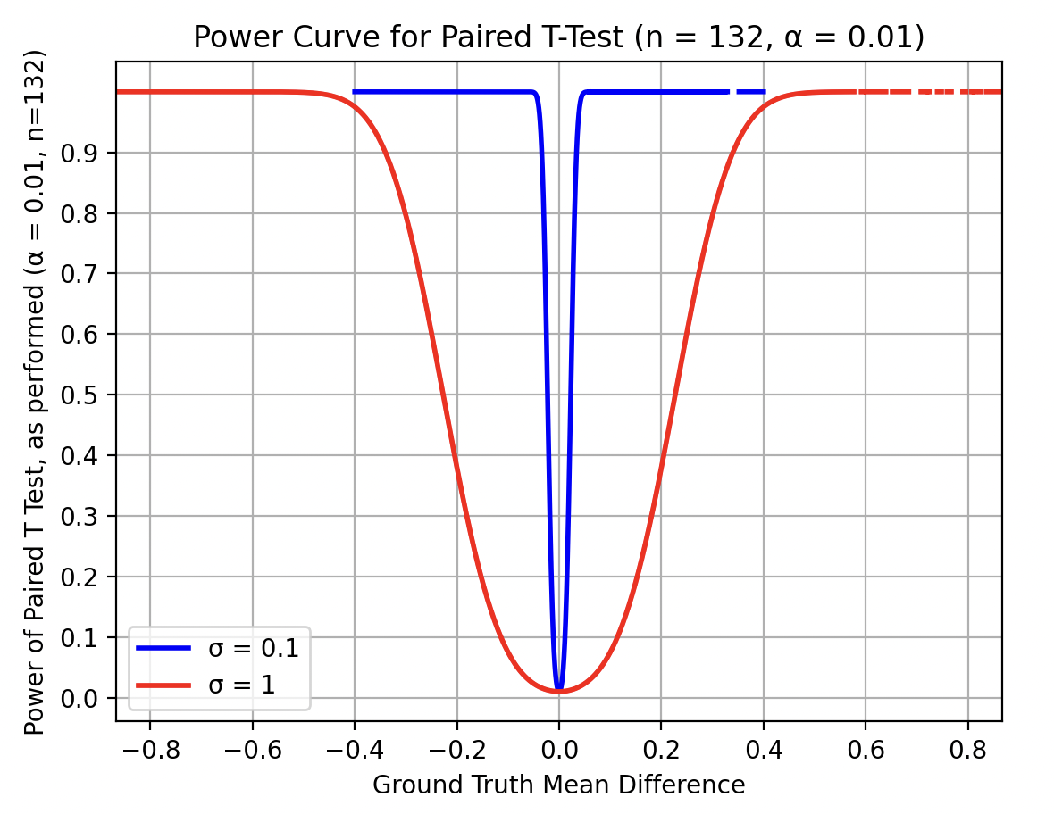

We project cancer incidence rates (/100k) at 80\% projected vaccine uptake, alongside number of routine screens, for all considered algorithms (Figure X). We report quantities (p-value), where p-value is derived from t-test, pairing on random simulation seed. If not otherwise specified, algorithms are tested against a baseline of current screening (V5U5A5). We use a p-value cutoff of 0.01 to determine significance: with n=132 simulations per scenario, this yields 80/% power for detecting changes in mean cancer incidence rate at ground truth absolute mean difference of at least 0.3 / 100k. When differences are significant, we report magnitude of Cohen’s d.

On a population-wise level, all but two modelled algorithms lead to similar incidence results; these exceptions are 10-yearly screening for all (V10U10A10) and the elimination of screening for vaccine-eligible individual, even when retaining current screening for the vaccine-ineligible subpopulation (V-U-A5). Inherent stochasticity of Agent-Based Modelling captures high aleatoric uncertainty in cancer outcomes, while our less stochastic compliance modelling yield lower-variance routine screening projections.

Targeted reduction of screening frequency for vaccinated individuals up to 15-yearly screening has little population-level impact. Reduction to from 5- to 7/10/15-yearly screening for the vaccinated increases mean projected population level incidence rates from 3.9 to 3.9/4.0/4.0 (p=.25/.12/.45) in 2040 and 2.6 to 2.7/2.7/2.7 in 2050 (p=.40/.38/<.001; d=-/-/0.18). Full removal of screening for vaccinated individuals yields significant and maintained population-level increase in cancer incidence: cancer incidence rate of 4.1 (p<.001, d=0.34) in 2040, and 3.1 (p<.001, d=0.58) in 2050. As the screening-eligible population becomes increasingly vaccinated over time, reduction from 5-yearly to 7/10/15-yearly screening for the vaccinated yields a population-level screening burden reduction of X/X/X \% in 2040 and X/X/X \% in 2050.

Uniform reduction of screening frequency for vaccine-eligible individuals up to 10-yearly screening has little population-level impact; reductions beyond this increase cancer incidence. Reducing screening from every 5 years (incidence rate 3.9) to every 7 years/10 years/15 years/never yields mean population level incidence rates of 4.0/4.2/4.7/5.6 (p=X/X/X/X) in 2040 and 2.7/2.8/3.0/4.8 (p=X/X/X/X) in 2050. Cohort-wise screening frequencies yield larger reductions in screening burden, with 7/10/15-yearly screening yielding a reduction over the full population of X/X/X \% in 2040 and X/X/X \% in 2050.

Hybrid screening intervals can yield equivalent incidence to corresponding vaccination-wise intervals, while permitting a lower screening burden. V10U7A5 yields incidence rate X/X and screening reduction of X/X \% in 2040/50; cancer incidence is not significantly different to V10U5A5 (p=.52/.08), V7U5A5 (p=.30/.08), or V7U7A5 (p=.41/.20), and significantly better than V10U10A5 in the short term (p<.001/=0.82; d=0.24/-).However, V15U10A5 yields incidence rate X/X and screening reduction of X/X \% in 2050; which, while not yielding significantly different cancer incidence to V10U10A5 (p=.90/.09), yields significantly worse cancer incidence than V15U5A5 in the short term (p<.001/=.06; d=0.35/-).

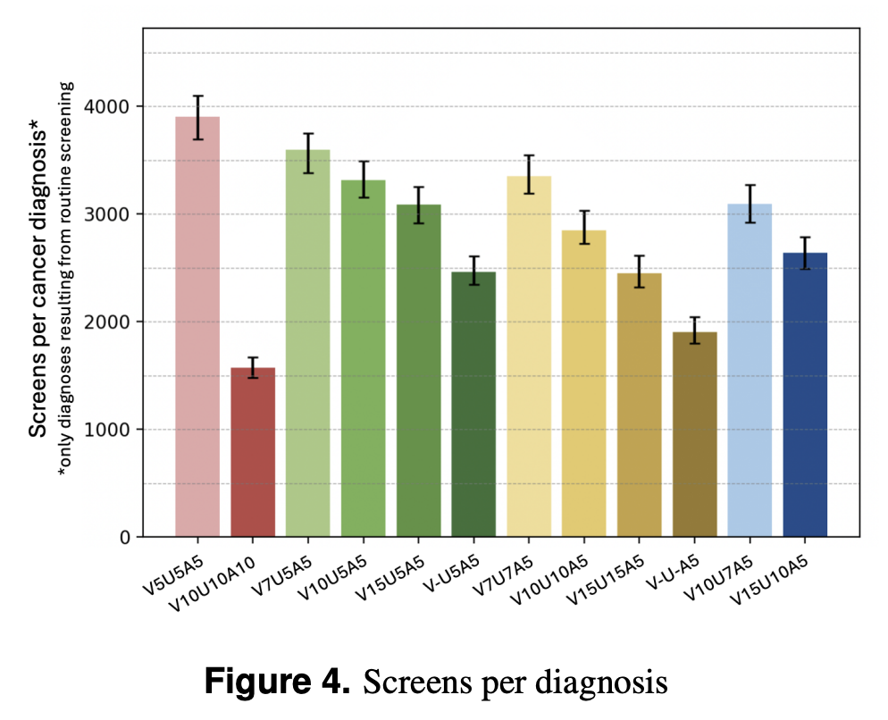 + this figure needs this plotted as a 4x3 where the rows are ‘full population’ (probs either removed in main body or the only row I end up showing in the main body, depending on how it all deviates from the results I already have, does it add to the story or is it just repeating the same ideas?) ‘non-vaccine eligible population’, ‘unvaccinated vaccine-elgiible’ and ‘vaccinated’ and the colums are ‘true vs observed HPV incidence’ (with a curve for true and then 4 curves for observed annual incidence rates for 5, 7, 10, 15 yearly screening on that subpopulation), ‘long-term undiagnosed cancer prevalence’ (this allows for some sort of compilation of the effect of lower screening frequency both on actual cancer burden and observed cancer burden, as well as being a metric of prevalence (which captures how screening can aid cancer detection and lead to curing of cancer, which incidence does not capture). A key thing to observe will be that the patterns r.e. prevalence are the same as those r.e. incidence (and I should observe this for subpopulations too – if the rows are uninterestingly similar to prevalence info then just do a population wise row for main body and be done, leaving rest to appendices!)), and then ‘screens per cancer diagnosis’, which does expectedly show that at least on a population level any modelled alg performs better than current.

Uses of these figures that need to be clarified in discussion:
- Screening is also used for surveillance, so it is important to see how lower frequences affect this. Though I suppose it would probably just be a matter of proportionally lower observed HPV incidence for each subpopulation, but I suppose a simulation to verify that doesn’t hurt?
- Screening does not just impact incidence (though critically it does impact incidence because it can catch CIN and treat with ablation before they develop into cancer, as well as identifying those who are HPV +ve to then screen them more frequently – and this behaviour I do not change as at the point of being identifies as HPV +ve it seems unreasonable to treat people differently depending on vaccine-status and definitely unreasonable depending just on vaccine-eligiblity). In fact, for those who do have cancer, lower screening will mean longer time to diagnosis. Therefore tracking undiagnosed cancer prevalence is important – and long-term undiagnosed cancer prevalence is being tracked as proxy for cancers which have been able to develop for long enough to be a later stage (which is associated with signficiantly worse prognoses).
  - This also requires proper statistical testing between screening algorithms in terms of this metric, therefore
  - Of course, if it turns out the relative patterns /relationships between different screening algorithms are the same for both ludp and incidence, then I can continue to use incidence throughout and don’t need to both much about this other than at this one section in order to make that argument that the two metrics agree in terms of the best screening algorithm
  - In that case, I think Long term undiagnosed cancer prevalcne could be taken away from the equity analysis as it adds potentially unnecessary detail; instead lets look at these alternative metrics here (also considering subpopulations iff needed, and if it does turn out to be needed then we will do the first equity analysis and then to the alternative metrics underneath it with the equity analysis immediately ‘built in’ instead)
- Screens/diagnosis is a metric closely related to health economics and therefore an important one to include for that

Detail for RESULT 2
“Screening according to vaccine-eligibility leads to greater inequity with worse outcomes for the unvaccinated vaccine-eligible as screening frequency decreases (incidence rate 8/6/4 LS: 0.9/1.3/1.7 2050). In contrast, a screening reduction for vaccinated individuals from 8 to 4 LS has negligible impact amongst the vaccinated (8/6/4 LS: 0.1/0.2/0.2 incidence rate 2050), but incidence increases at lower screening frequencies (3LS: 0.4 incidence rate 2050).”

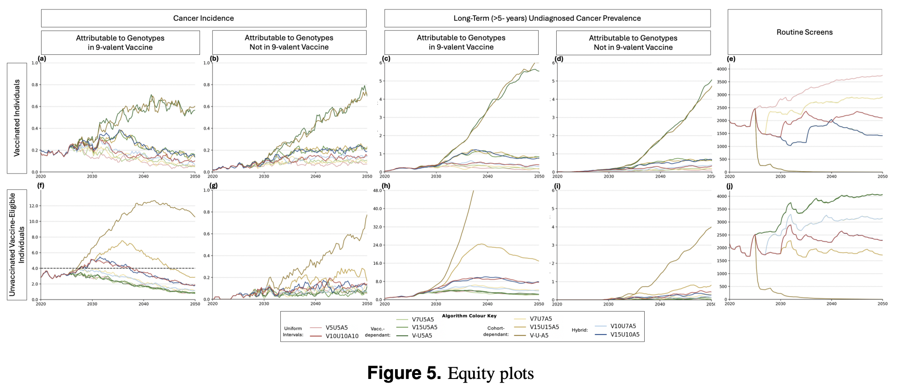
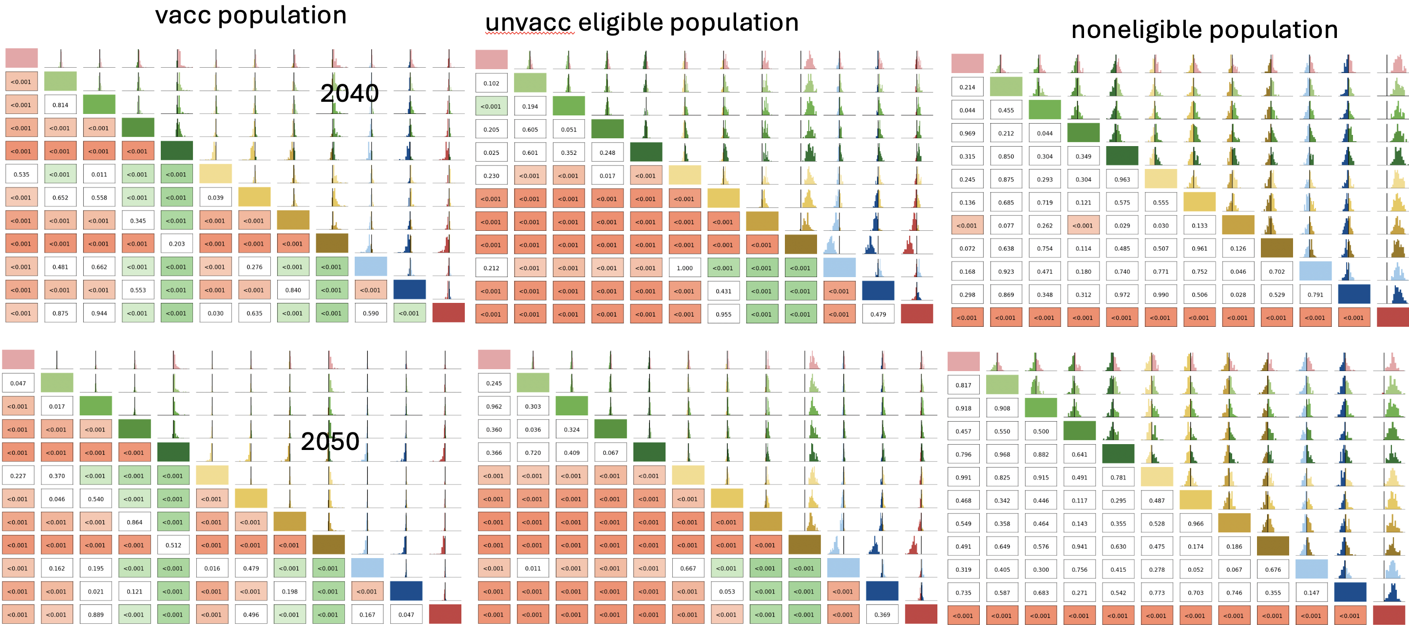
- But do not forget to look for the t values and interpret using cohen’s d as clearly some effect sizes are larger than others even when significant! https://www.statology.org/interpret-cohens-d/
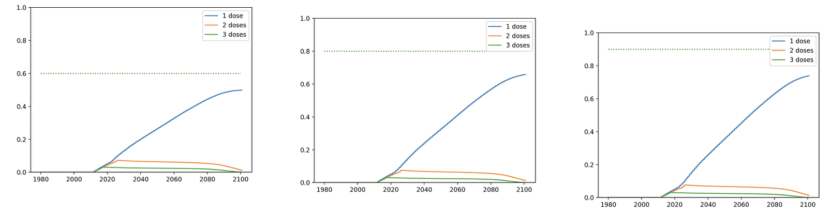
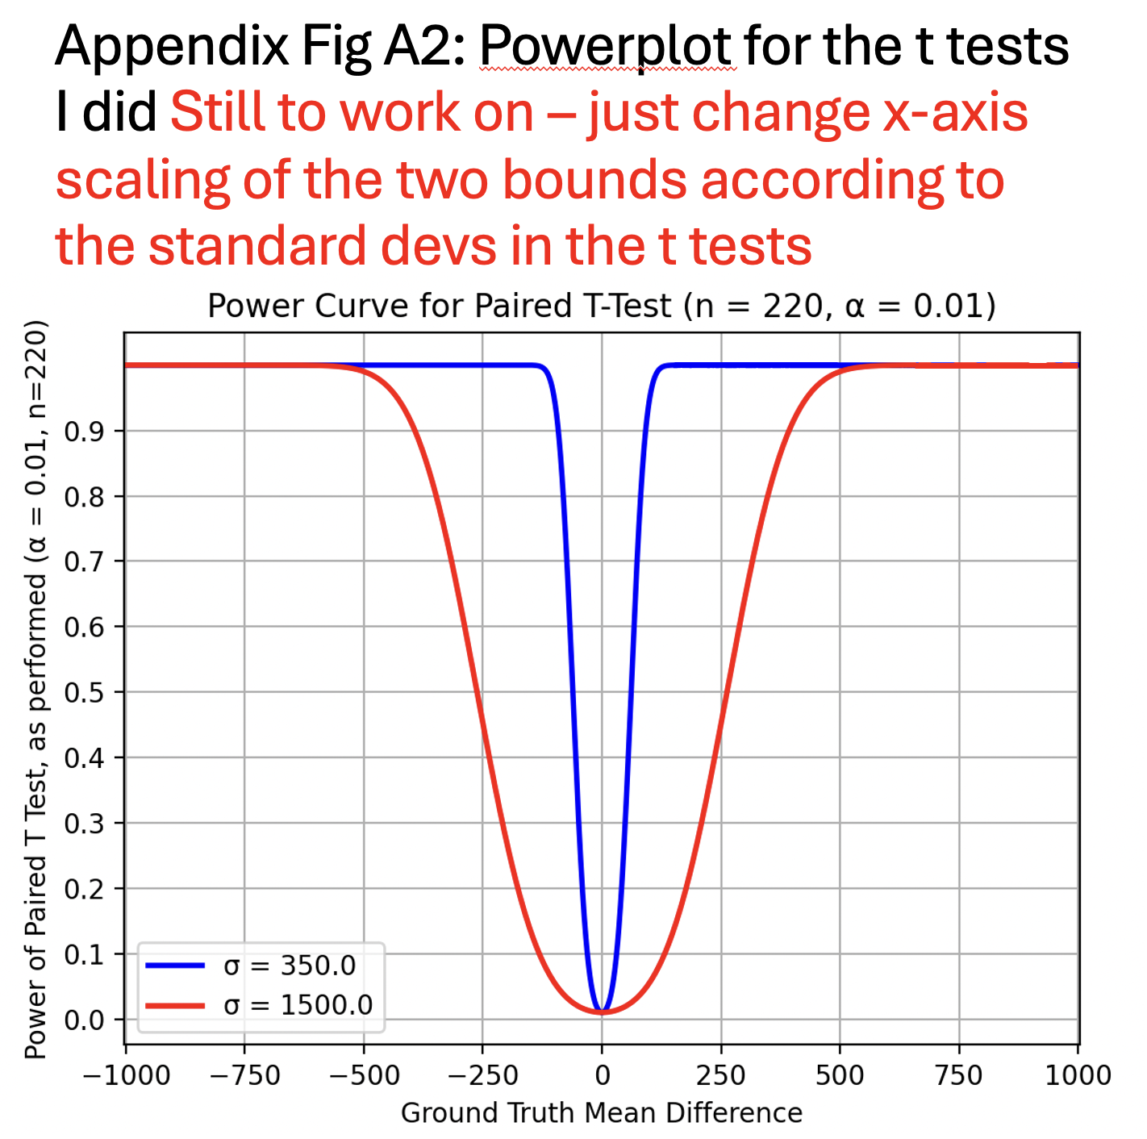

We perform a subpopulation analysis,

Detail for RESULT 3
“While a reduction in vaccine uptake to 60\% will require more total screening for unvaccinated people across the population, individual lifetime screens can remain at 6 LS for the unvaccinated vaccine eligible and 4 for the vaccinated to retain current incidence rate projections.”

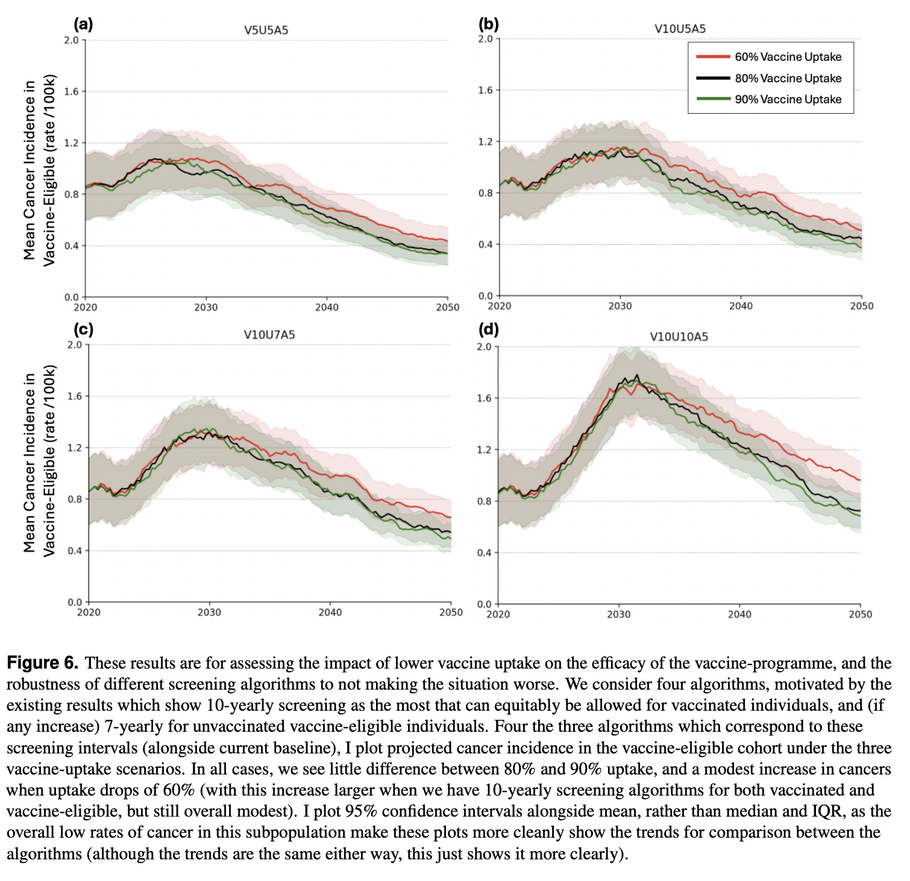


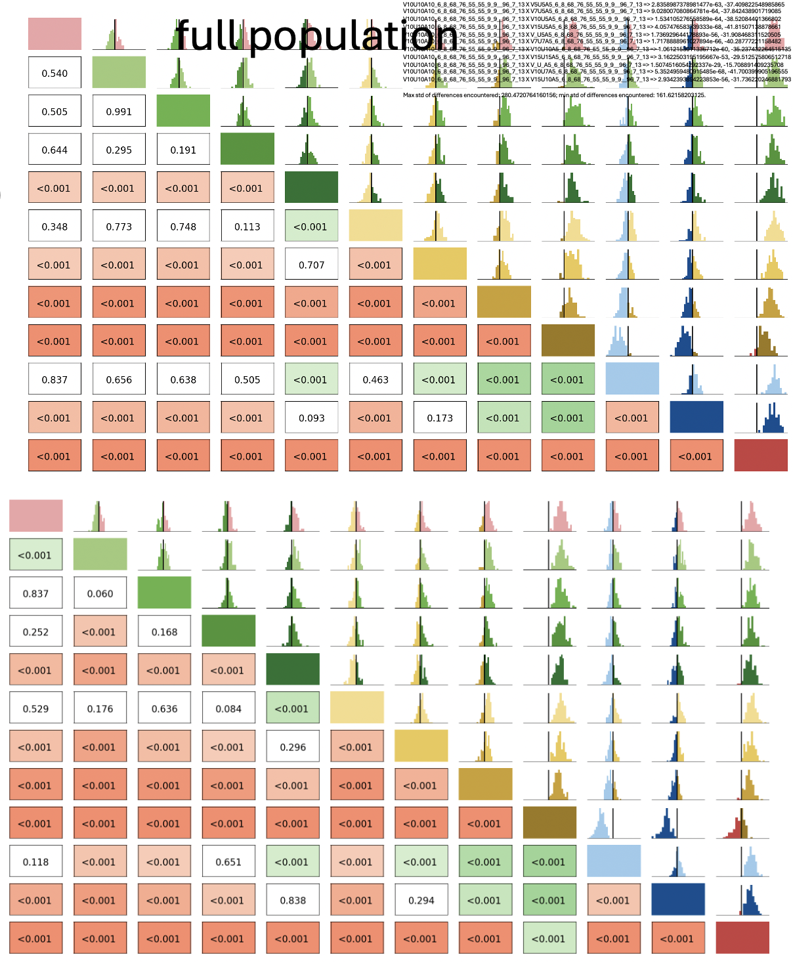
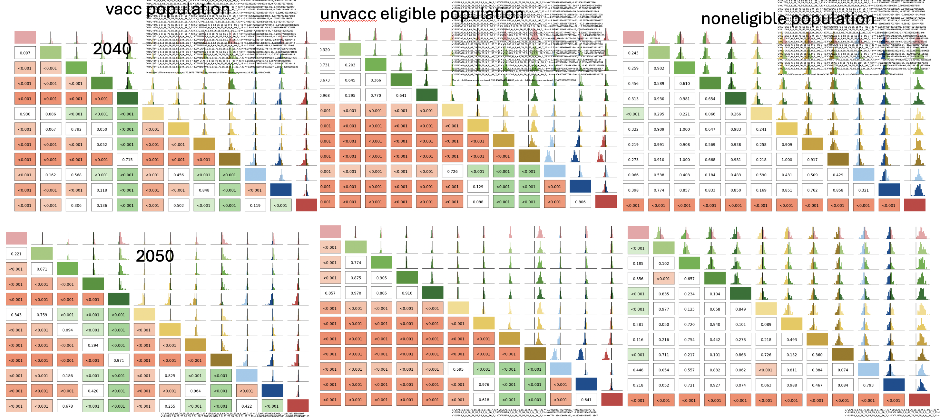

Detail for RESULT 4
“Under the current English screening policy, population-level cervical cancer elimination is unlikely by 2040 (elimination probability 22\%), more likely by 2045 (elimination probability 75\%) and very likely by 2050 (X)”
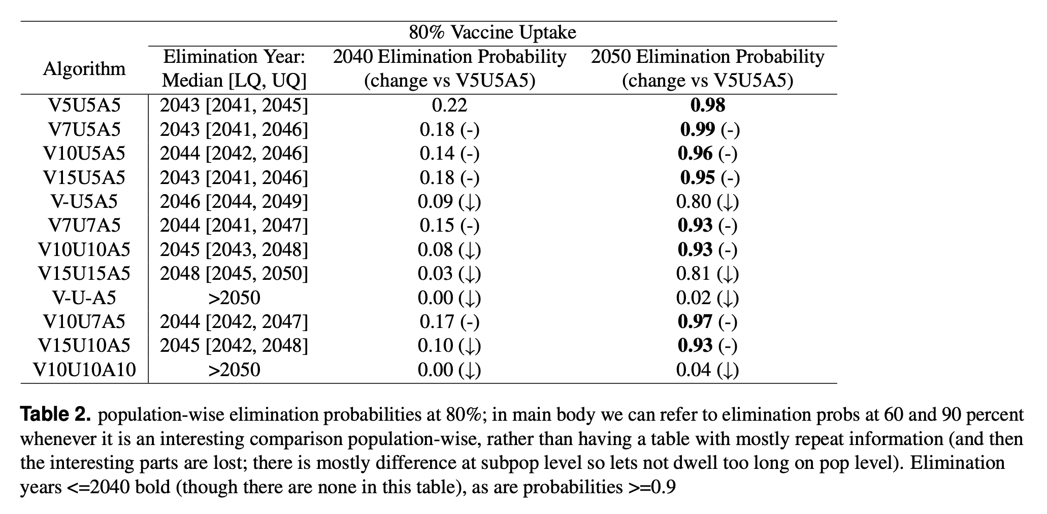
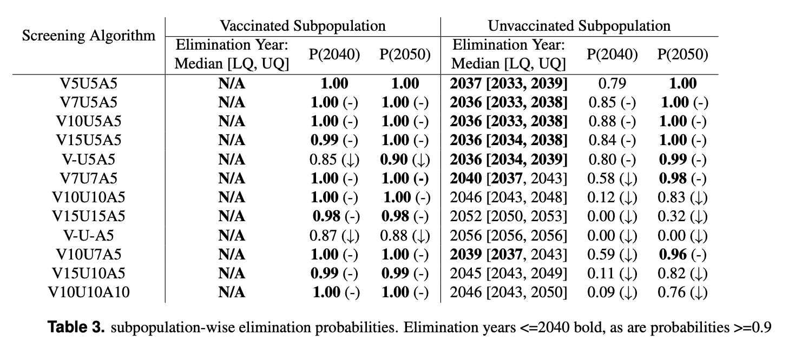

Discussion points from which the abstracts conclusions are derived
[to be added]

Comparing our results + discussion points to literature
[to be added]

Limitations
[to be added]

